*Laboratory Report*

**INTERNET TECHNOLOGIES LAB.**

**CAP5004L**

**School of Engineering**

**Department of Computer Science and Engineering**

|  |  |
| --- | --- |
| **Submitted By** | |
| **Student Name** | Amit |
| **Roll Number** | 180020307001 |
| **Section/Group** |  |
| **Department** | Computer Science and Engineering |
| **Session/Semester** | 2020-21/ Odd Semester |
| **Submitted To** | |
| **Faculty Name** | Ms. Manka Sharma |



**GD Goenka University**

Sohna road, Gurugram, Haryana

**Table of Content**

|  |  |  |  |
| --- | --- | --- | --- |
| Sl No | Date | Aim of the Experiment | Signature/date |
|  |  |  |  |
|  |  |  |  |
|  |  |  |  |
|  |  |  |  |
|  |  |  |  |
|  |  |  |  |
|  |  |  |  |
|  |  |  |  |
|  |  |  |  |
|  |  |  |  |

|  |  |  |
| --- | --- | --- |
| **Experiment No- 7.1** |  | **Date:** |

**Aim of the Experiment:**

Write a JavaScript for loop that will iterate from 0 to 15. For each iteration, it will check if the current number is odd or even, and display a message to the screen.

**Source Code**

<!DOCTYPE html>

<html lang="en">

<head>

<meta charset="UTF-8">

<meta name="viewport" content="width=device-width, initial-scale=1.0">

<title>Document</title>

</head>

<body>

<div id="data"></div>

<script>

div = document.getElementById('data');

for(var i = 1; i <= 15 ; i++) {

div.innerHTML += i % 2 === 0 ? i + " >>> Even<br>" : i + ' >>> Odd<br>';

}

</script>

</body>

</html>

**Output**

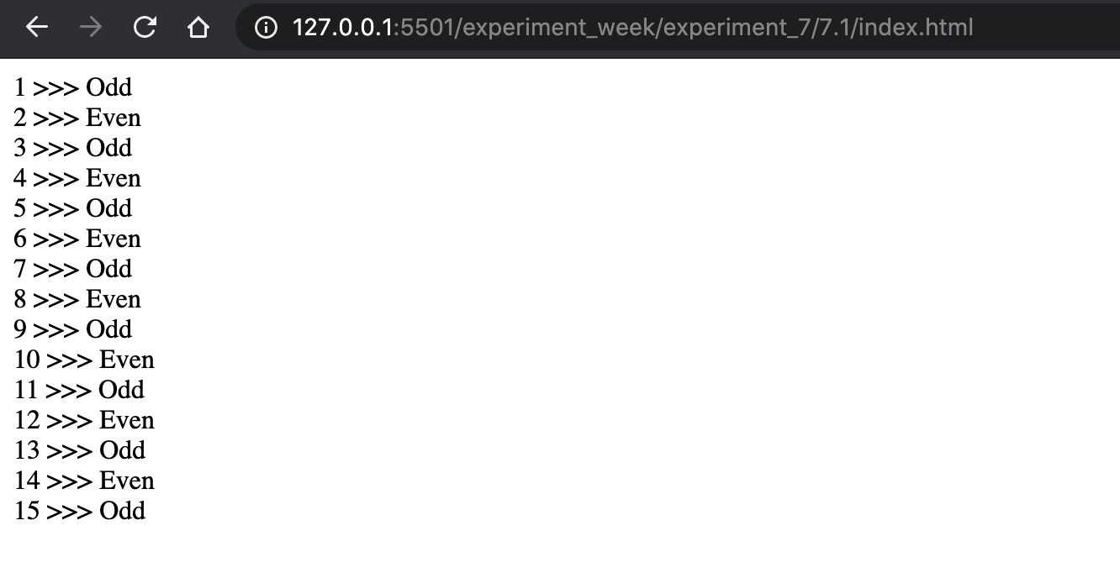

|  |  |  |
| --- | --- | --- |
| **Experiment No- 7.2** |  | **Date:** |

**Aim of the Experiment:**

Write a JavaScript program to compute the greatest common divisor (GCD) of two

positive integers.

**Source Code - index.html**

<!DOCTYPE html>

<html lang="en">

<head>

<meta charset="UTF-8">

<meta name="viewport" content="width=device-width, initial-scale=1.0">

<title>Document</title>

</head>

<body>

GCD: <div style="display: inline-block;" id="data"></div>

<script>

var gcd = function(a, b) {

if (b == 0) {

return a;

}

return gcd(b, a % b);

};

document.getElementById('data').innerText = gcd(4,8)

</script>

</body>

</html>

**Output**

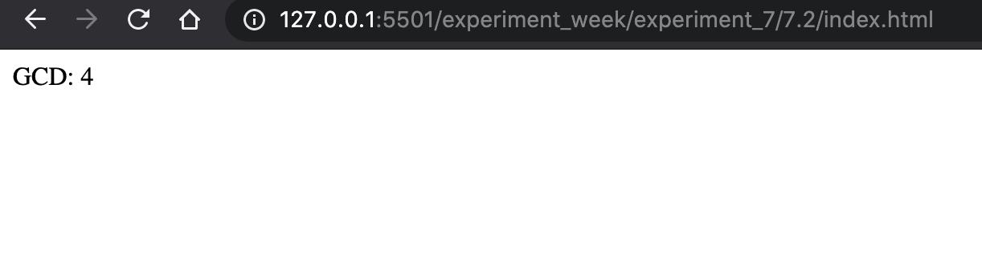

|  |  |  |
| --- | --- | --- |
| **Experiment No- 7.3** |  | **Date:** |

**Aim of the Experiment:**

Write a JavaScript program to sum the multiples of 3 and 5 under 1000.

**Source Code**

<!DOCTYPE html>

<html lang="en">

<head>

<meta charset="UTF-8">

<meta name="viewport" content="width=device-width, initial-scale=1.0">

<title>Document</title>

</head>

<body>

SUM: <div style="display: inline-block;" id="data"></div>

<script>

var sum = 0;

for(var i = 1; i <= 100; i++) {

if(i % 3 === 0 && i % 5 === 0) {

console.log(i);

sum += i;

}

}

document.getElementById('data').innerText = sum;

</script>

</body>

</html

**Output**

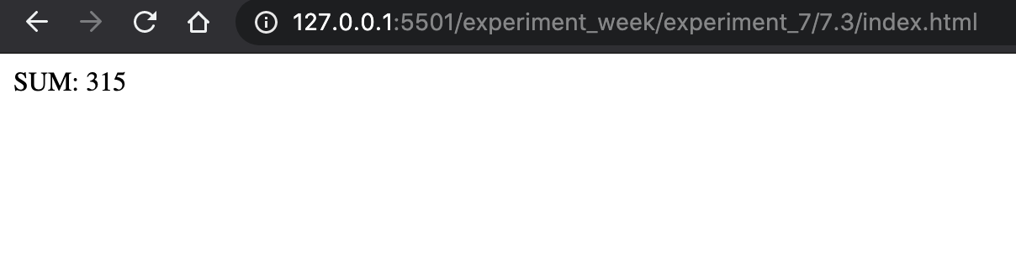

|  |  |  |
| --- | --- | --- |
| **Experiment No- 7.4** |  | **Date:** |

**Aim of the Experiment:**

Write a JavaScript program to sum all the elements of an array.

**Source Code**

<!DOCTYPE html>

<html lang="en">

<head>

<meta charset="UTF-8">

<meta name="viewport" content="width=device-width, initial-scale=1.0">

<title>Document</title>

</head>

<body>

SUM: <div style="display: inline-block;" id="data"></div>

<script>

var sum = 0, a = [12,34,21,45,56,3,2,5,1,90];

for(var i = 1; i < a.length; i++) {

sum += a[i];

}

document.getElementById('data').innerText = sum;

</script>

</body>

</html>

**Output**

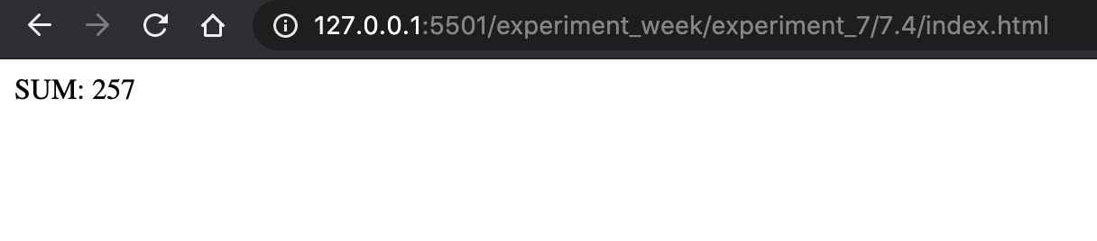

|  |  |  |
| --- | --- | --- |
| **Experiment No- 7.5** |  | **Date:** |

**Aim of the Experiment:**

Write a program in JavaScript to find the factorial of a number accepted from the user.

**Source Code**

<!DOCTYPE html>

<html lang="en">

<head>

<meta charset="UTF-8">

<meta name="viewport" content="width=device-width, initial-scale=1.0">

<title>Document</title>

</head>

<body>

Factorial: <div style="display: inline-block;" id="data"></div>

<script>

var fact = (num) => {

var sum = 1;

for(var i = 1; i <= num; i++) {

sum *=i;

}

return sum;

}

var num = parseInt(prompt("Enter number: "));

document.getElementById('data').innerText = fact(num);

</script>

</body>

</html>

**Output**

